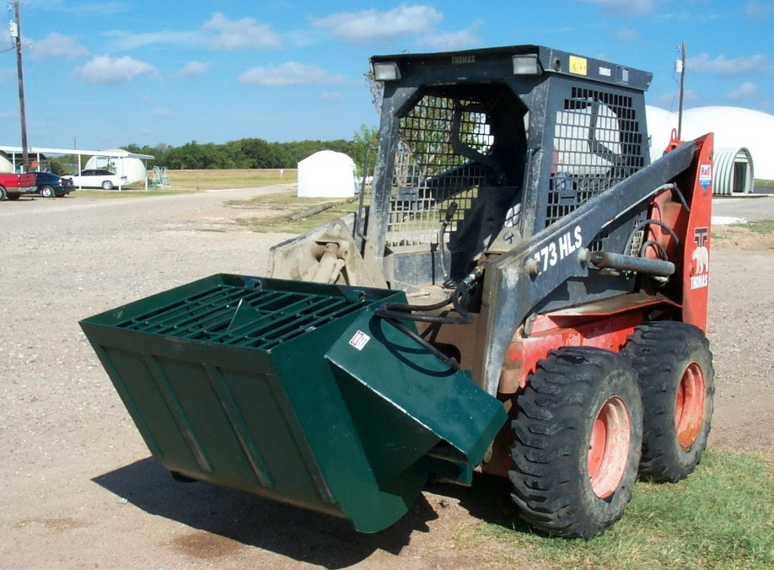

Owner’s Manual
SupermixR
Part #CMB

Operation Instructions
The SupermixR is equipped with the universal mount plate that fits most of the skid steer loaders. Therefore, the mixer will be mounted in place of the bucket.
Using the mount plate on the tractor, attach the mixer to the skid steer and then connect the hoses to the auxiliary power on the tractor.
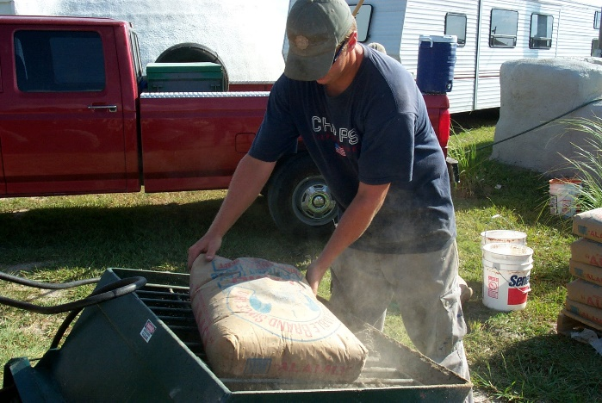
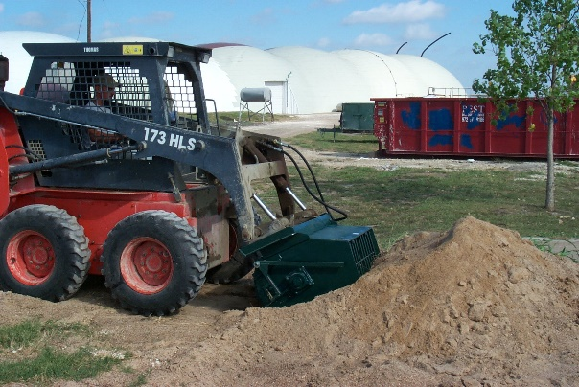
The loading the mixer by driving the skid steer with the Cart-Away SupermixR into the sand or aggregate pile (Your material selection will be based upon your particular mix recipe). The Bucket is tilted down and pushed into the pile, then tilted back to vertical. Check for the correct amount of material. You may need to add some material to achieve a full bucket.
Next, drive the Bucket to where you are storing the bags of Portland cement. Break one or two bags into the bucket (this will depend upon your particular mix recipe).
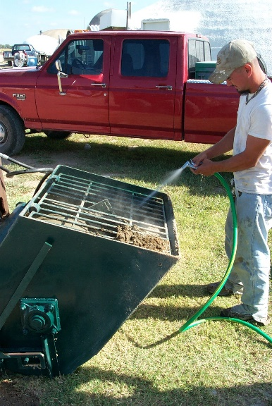
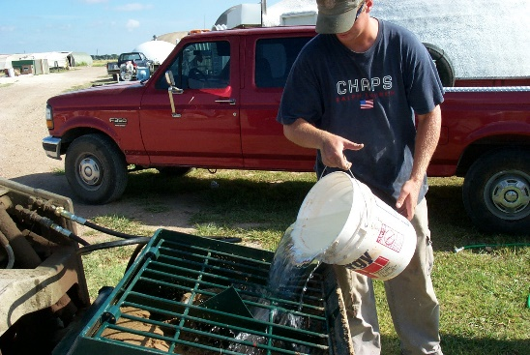
Add water until you have achieved your desired consistency.
Blend in any additives that would be helpful in achieving your desired mix recipe.

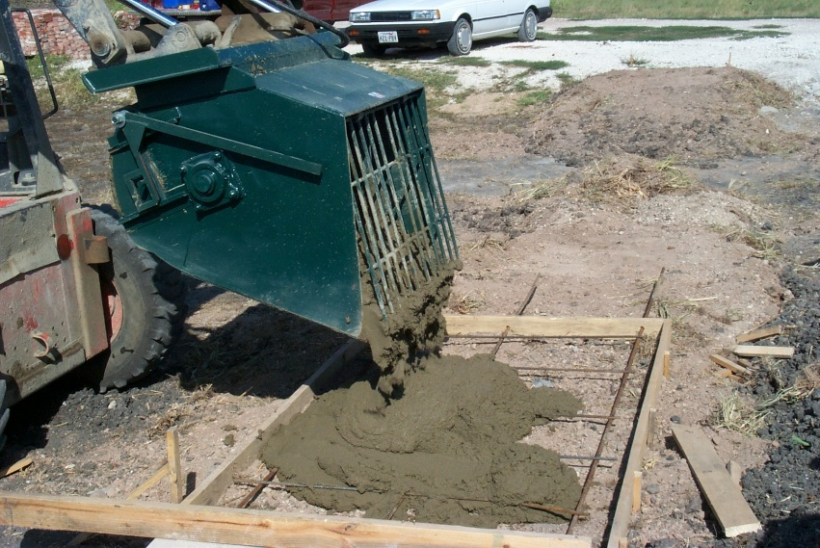
Mix until you have the consistency you desire.
Move the mixer to dump into the Skweez pump or into the forms.
Rinse the Bucket and go for a refill, or complete a thorough clean-up of all surfaces.
NOTE: Cleaning your Cart-Away concrete equipment is the best insurance of maintaining a long service life.
Maintenance:
- A hydraulic motor drives a gearbox. This added gearbox gives you more power. The gearbox needs to be checked for oil level from time to time.
- On the opposite side of the from the motor/gearbox is a bearing supporting a shaft. This is a sealed bearing and needs to be greased prior to every use.
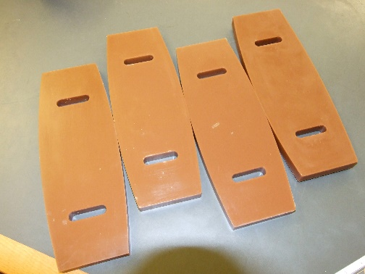
- The paddle pads are slotted to be adjustable and reversible. As the pads wear, they can be adjusted closer to the barrel of the mixer. As one side wears out the pads can be turned over.
- Your SupermixR has two hydraulic hoses with quick connection, “Flat-Face” fittings. You may need to change these to better marry-up to your tractor auxiliary power supply.

Call Customer Service at: 800-909-9809 1405 NE Alpha Dr. McMInnville, Oregon 97128

